INGLÉS – 3er año- Actividades de continuidad pedagógica-

Clase 1 (Lunes 16/03)

Las actividades que vas a encontrar a continuación son actividades de revisión de los contenidos vistos el año pasado.

1. Read the text bellow. Are the sentences true (T) or false (F)?

# Christina Aguilera

Christina Maria Aguilera was born in New York on December 18th, 1980. her father is from Ecuador and her mother is from Ireland. Christina always wanted to be a star. At the age of 8, she appeared on a talent show on America TV, and in 1992 she started her professional career in a TV show called The New Mickey Mouse Club.

In 1994, the show finished and Christina decided to concentrate on music. She travelled a lot and played in different countries, including Japan and Romania. In 1999, she finished her first CD, called “Christina Aguilera”. The CD was number one in the USA.

Christina has songs with Enrique Iglesias, and Bono, from U2. She is now an international superstar. She works very hard and she has fans all over the world. In her free time, she likes buying clothes and going to restaurants. She likes eating food from different countries.

1. Christina Aguilera is American. …………………..
2. Christina is an adolescent, she appears on a talent show on TV. ……………….
3. Christina never visits Japan. ……………………
4. Her first CD is very popular in the USA. ……………….
5. Christina never eats in restaurants. ………………….
6. Look at the table.

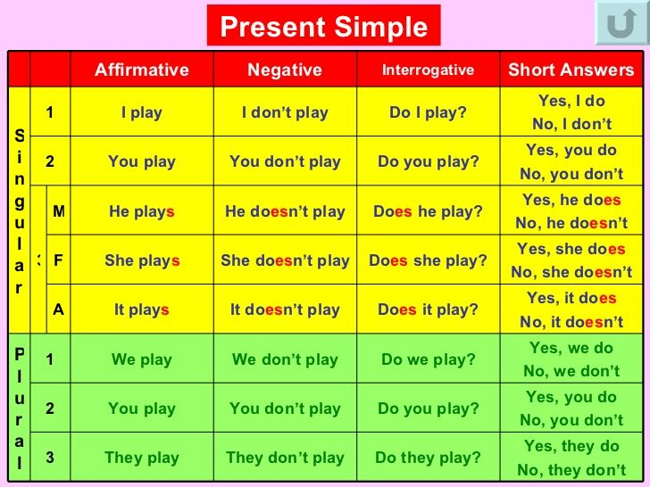

1. Complete the following activities.

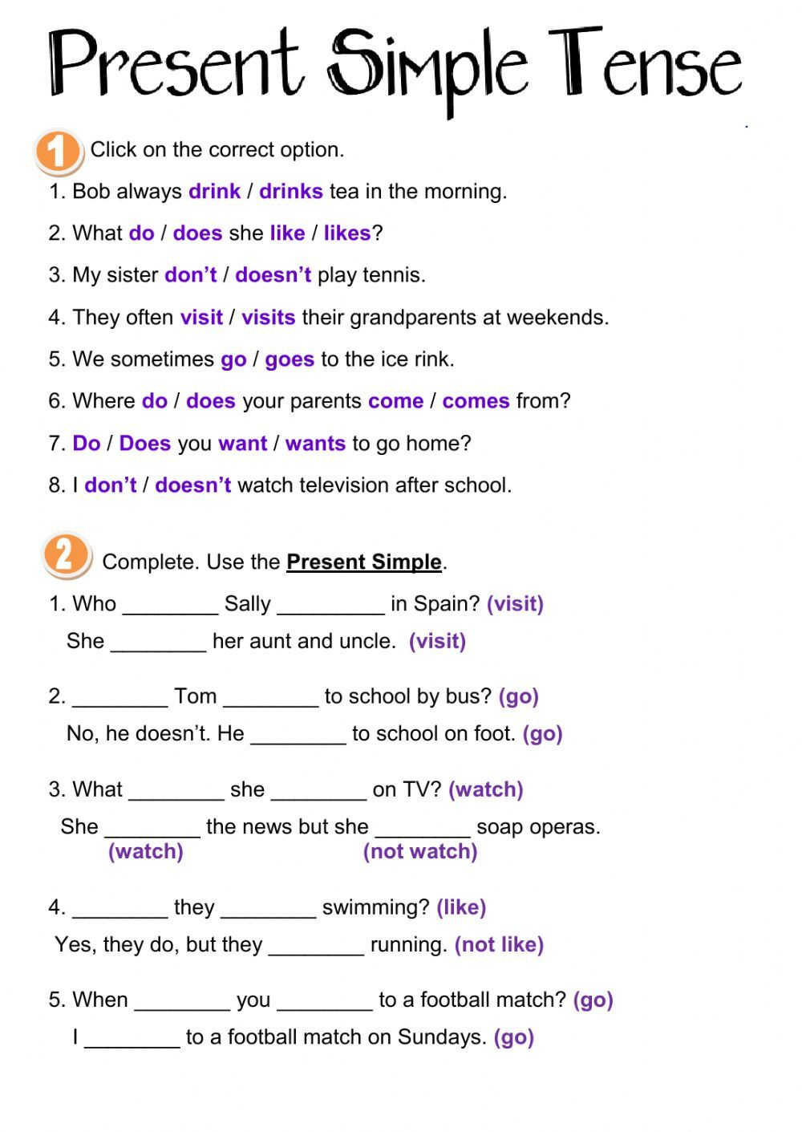

Clase 2 (Jueves 19/03)

1. Read the text.

ACTIONS HAPPENING NOW

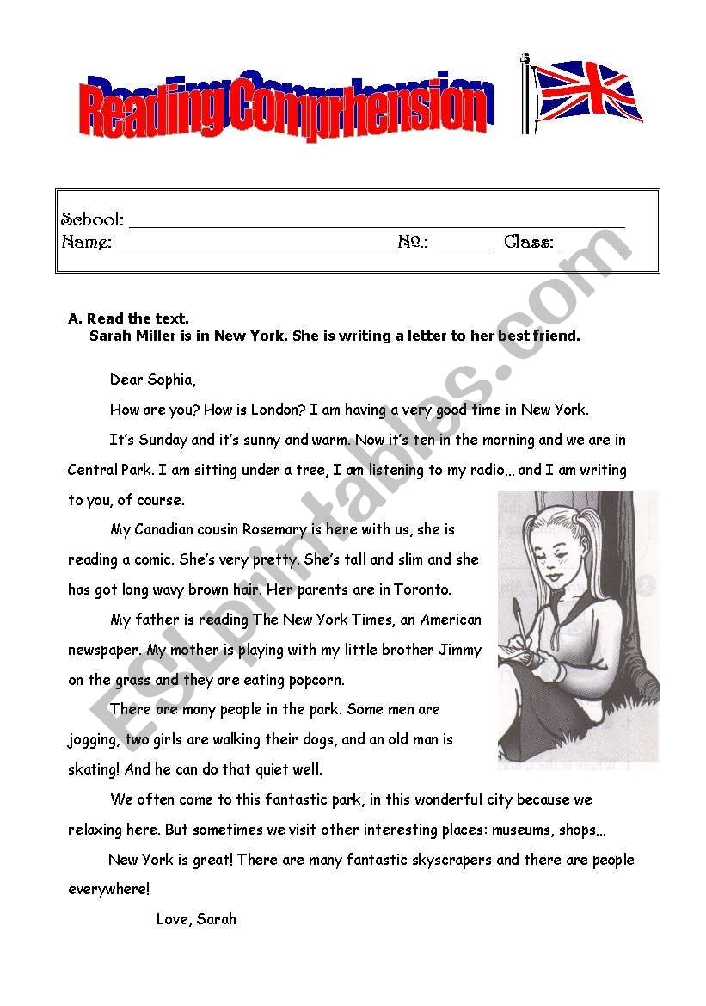

1. Answer the questions.
2. Where is Sarah? …………………………………………………….
3. Where is Sarah sitting? ……………………………………………………………..
4. What is she doing? ……………………………………………………………………
5. What is her father doing? …………………………………………………………………..
6. What is her mother doing? …………………………………………………………………
7. What are the people doing in the park? …………………………………………………………..

*Usamos el Presente Continuo para hablar de las acciones que estan sucediendo en este momento. Aquí van algunos ejemplos.*

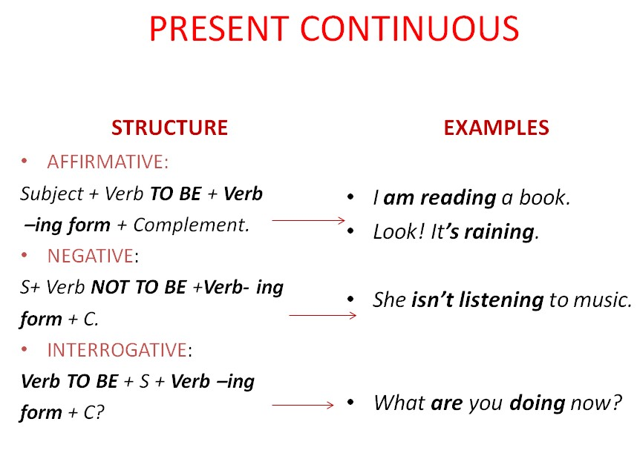

REGLAS DE ORTOGRAFIA PARA AGREGAR “ING”

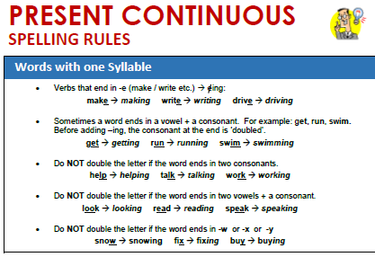

1. Completá la oraciones usando el PRESENT CONTINUOUS.

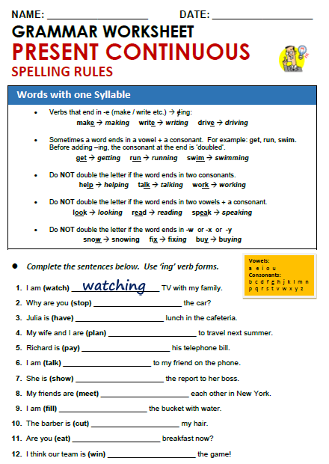

1. ***RUTINAS Y ACTIVIDADES QUE ESTAN SUCEDIENDO EN ESTE MOMENTO****.*

Diferenciar entre el presente simple y presente continuo.

Complete the sentences with SIMPLE PRESENT or PRESENT CONTINUOUS:

Susan usually ………………. (go) to school by bus, but now she …………………….. (go) to school by train. 2. Mary often ……………….. (read) in bed, but today she is very tired and she ………………………. (not / read). 3. The boys usually ………………… (ride) their bikes to school. They ……………. ………………… (like / ride) their bikes. They ……………… (be) very naughty boys. They always …………………… (go) to school late. Today their teacher …………………. (be) very angry, because they ………………… (be) late again. 4. Mary ……………………….. (like / eat) sweets. Every morning she ……………. (have) coffee with a lot of sweets and chocolate. For lunch she and her friends often ……………….. (eat) sweets or ice-cream. She ……………………… (not / like / eat) fruit or vegetables. She ……………………… (eat / never) eggs or cheese. Today she ………………….. (be) sick. She …………………… (sleep) in her room now.