INGLÉS – 5to año- Actividades de continuidad pedagógica-

Clase 1 (Miercoles 18/03)

Hi dear students! We are going to do some revisión activities during this period. If you have any doubts you can email me.

(¡Hola queridos alumnos! Vamos a estar haciendo actividades de revisión durante este periodo. Si tienen aluna duda me pueden mandar un email.)

**Reading**

Read the text about Amsterdam and choose the correct answers.

**1** Eddy has been a student for _____ years.

**a** two **b** three **c** four

**2** In Amsterdam, Jonathan stayed

**a** at the wooden house. **b** in a hotel. **c** at Eddy’s place.

**3** Jonathan visited two _____ in Amsterdam.

**a** museums **b** canals **c** friendly people

**4** Eddy took Jonathan to

**a** a flower garden. **b** an amusement park. **c** the city centre.

**My friend, Jonathan, has recently visited the Netherlands. His older brother, Eddy, is a law student in Amsterdam.** He has lived there for four years but Jonathan has never had a chance to visit him. Last month he finally decided to go to Amsterdam. He bought a plane ticket and reserved a room in a hotel near Eddy’s apartment for a week.

On the first day, Eddy took his brother on a sightseeing tour around Amsterdam. Jonathan was really happy. He loved the clean city with its beautiful old buildings, historic canals and very friendly people. He visited the famous Rijksmuseum to see the Dutch paintings by Rembrandt. He also went to the Van Gogh Museum. He liked the wooden house in Begijnhof, a very old house from 1470. It is probably the oldest wooden house in the Netherlands.

Jonathan was surprised at the public transport in Amsterdam. It was very well organised. Because it was expensive to park in the city centre, many people travelled to work on their bikes. To see more of the city Jonathan used his brother’s bike and found it was a quick and convenient means of transport.

On the last day Eddy took Jonathan to Efteling, a large theme park similar to Disney World in Florida. They spent eight hours having fun on the different rides and relaxing in cafés.

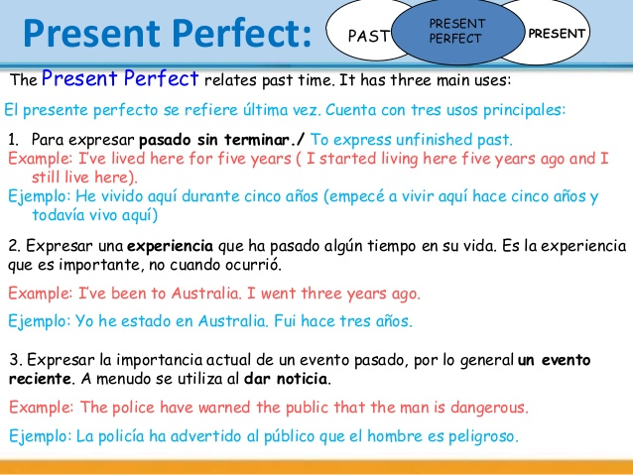

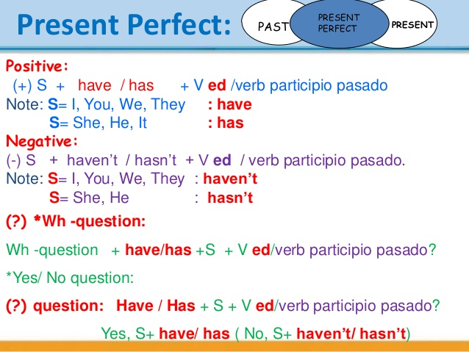

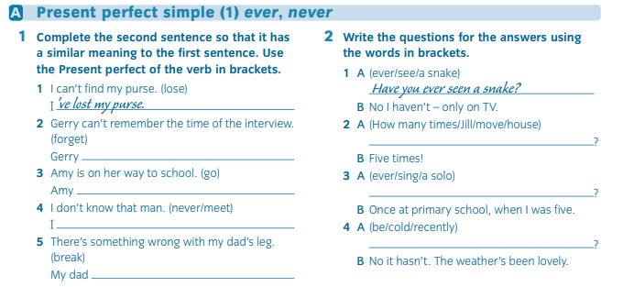

PRESENT PERFECT

Put the verbs in the correct form of the Present Perfect

1. How long ______ (he / live) in New Jersey?
2. Peter ______ (not play) baseball since 1987.
3. I ______ (speak) Russian for twenty years.
4. We _____ (not see) Tom since Christmas.
5. ________ (Alan / fly) in an airplane before?
6. Shannon _____ (not / go) to lunch yet.
7. Our class _____ (take) a field trip three times this year.
8. Where _____ (they / move) to?
9. Jennifer _____ (ask) that question four times today.
10. You _____ (not eat) lunch yet, have you?