COLEGIO SEÑOR DE MAILÍN
PLAN DE CONTINUIDAD PEDAGÓGICA
PROF. JESSICA REYNOSO
INGLÉS: 2DO AÑO
19 DE MARZO
LET’S WORK!

- Read about Sarah.
Hello! I am Sarah and I live in London, England. I am 13 years old. I have got 1 brother, He is John. He is 22 years old. I live with my father and mother. I have got a cat. I am tall and thin. I am intelligent and friendly. I have got long hair and green eyes. My favourite subject at school is Science. I love doing experiments. I like P.E because I like sports. My favourite sport is football and my favourite food is chicken and chips. I go to school at 7 o’clock. My school is big and old. Classes start at 8 o’clock and finish at 1 o’clock. On Mondays I have English, Science and Maths. Monday is my favourite day at school!

True or false?

- John is 13 years old. __________
- Sarah lives with his mother and father. ____________
- She has got two cats. _____________
- She has got green eyes. ______________
- Her favourite sport is P.E. ______________
- She likes Science. _______________

- Complete the sentences with the verb BE (is- are- am)

- Sarah __________ (+) 13 years old.She ___________ (+) from England. She _________(-) American.
- I _____________ (-) 16 years old. I am Brazilian. I __________(+) from Brazil.
- We ____________(+) students. We ___________(-) from China. We _____________ (+) Japanese.
- _______ they friends? Yes, they __________. They are American.
- ________ your teacher English? No, she __________. She is German.

3- Complete the sentences with the verbs in the PRESENT SIMPLE.

A- I _____________________(HAVE LUNCH) at one o’clock.(+)
b- The boys _________________ (PLAY) computer games every day. (-)
c- Sonia always __________________ (WATCH) TV at night. (+)
d- _______ you ________________ (EAT) pizza on Saturdays?
e- Tom _____________________ (GO) to the gym in the morning. (-)
f- ________ Sonia _______________ (LIVE) in a flat?

4- Complete the sentences with the verbs in the PRESENT CONTINUOUS.
1- I _________________________________ (listen) to music now. (+)
2- Susan ______________________________ (clean) the house. (+)
3- We _______________________________________ (eat) ice cream now. (-)
4- _________ you ______________________________ (study) English?
5- I ___________________________________________ (watch) TV at the moment. (-)
6- __________ she _________________________________ (help) her mother?

20 DE MARZO
MORE PRACTICE
1- Complete the sentences with the verb “BE”
1- I ________ A GOOD STUDENT. 2- MY SISTER ____________ 14 YEARS OLD. 3- WE ___________ FROM SPAIN. 4- TOMY __________ FROM ENGLAND. 5- YOU ___________ MY BEST FRIEND. 6- MY DOG __________ OLIVER.
2- Write these sentences in the negative and interrogative.
1- I am sixteen years old. _______________________________________________________ 2- My sister is a doctor. _________________________________________________________ 3- We are good at Maths. _________________________________________________________ 4- Jason is my brother. __________________________________________________________ 5- Lucy and Tom are at school. ______________________________________________________
3- Choose the right option. Write.PRESENT SIMPLE OR CONTINUOUS?

1.Marie ______________now. IS COOKING COOK COOKS
2. __________________everyday? DO YOU STUDY ARE YOU STUDYING YOU STUDY
3. I hardly ever _________________shopping. GO GOES AM GOING
4. Susan _________________________ a party today. IS GOING GOING GOES
5. Peter never ________________ in the morning. STUDY STUDIES IS STUDYING
6. _______________on holidays every year? DOES SHE GOES DOES SHE GO SHE GOES
7. Mum ______________lunch at the moment. PREPARES IS PREPARING PREPARING
8. Alice ______________ to work at the weekend. NOT GO DOESN’T GO ISN’T GO
9. I________________the washing up now. AM DOING DOING DO
10. My dad always ___________ the cooking. DO DOES DOING
4- Complete the following sentences with present simple or present continuous
1. Hello! Where __________you ________________ (go) now?
2. I usually (do) _______________my homework after dinner.
3- The lesson (begin) ___________________at 8 every morning.
5- He sometimes (go) ____________________to the pub.
6- I (not- listen) _____________________to the radio very often.
7- The shop (open) _________________at 8 o‘ clock every day.
8- He (not- come) ________________________to visit my mother every week.
10- He (study)________________________ English this year.
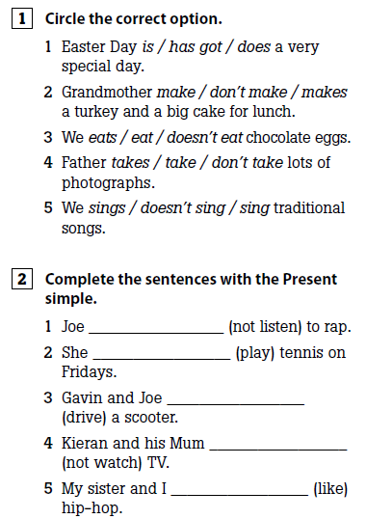
26 DE MARZO
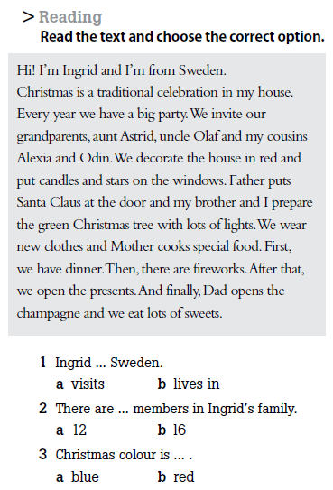

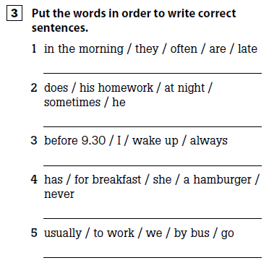
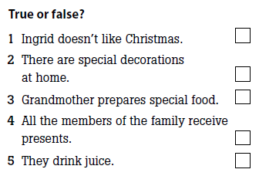

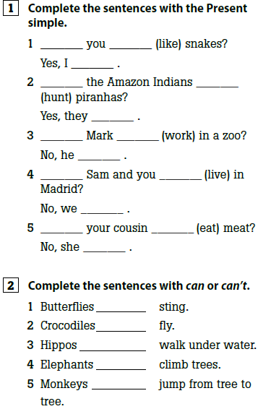
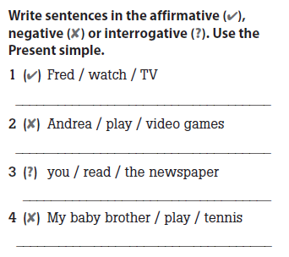
27 DE MARZO

