COLEGIO SEÑOR DE MAILÍN
PLAN DE CONTINUIDAD PEDAGÓGICA
PROF. JESSICA REYNOSO
INGLÉS: 1ER AÑO
17 DE MARZO
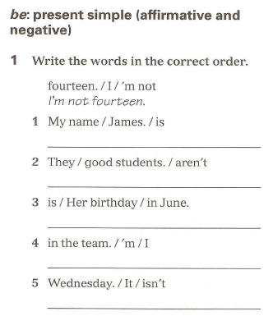
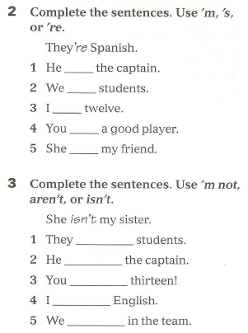
LET’S REVISE!

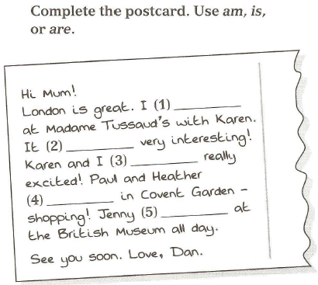
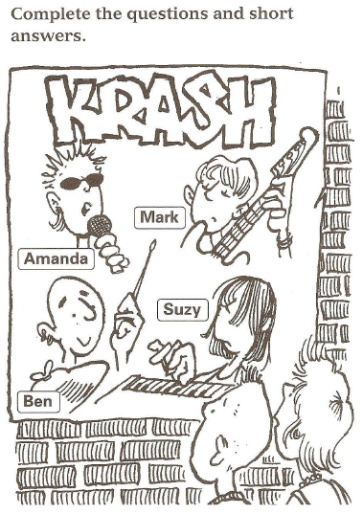

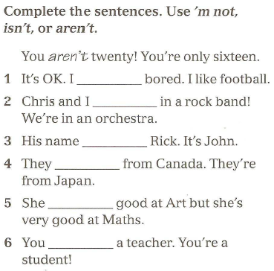

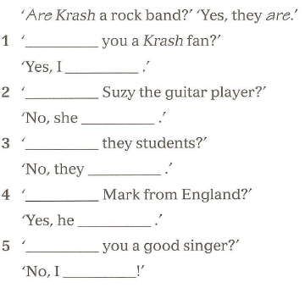

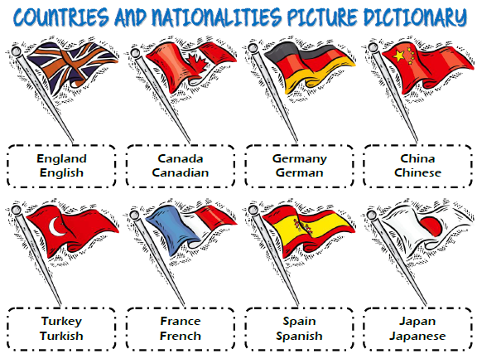
19 DE MARZO

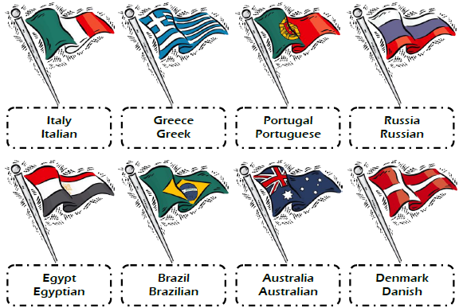

- Write the COUNTRY or NATIONALITY

1- Tom and Leila are Spanish. They are from _______________. 2- I am American. I am from _____________________. 3- My sister is from France. She is _______________________. 4- Where are you from? I am from Germany. I am ________________________. 5- Lucas is from Denmark. He is ________________________. 6- Are your grandparents Japanese? No, they are from China. They are ___________________.

2- Complete using with the verb BE: IS- AM- ARE

- Sarah __________ (+) 13 years old. She ___________ (+) from England. She _________(-) American.
- I _____________ (-) 16 years old. I am Brazilian. I __________(+) from Brazil.
- We ____________(+) students. We ___________(-) from China. We _____________ (+) Japanese.
- _______ they friends? Yes, they __________. They are American.

26 DE MARZO
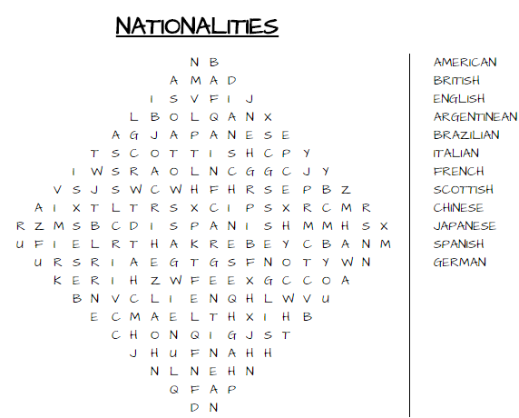
1- FIND THE WORDS IN THE WORDSEARCH

HAVE GOT
We use it to express POSESSION
I HE
YOU HAVE GOT SHE HAS GOT
WE IT
THEY
EXAMPLES: I HAVE GOT A DOG SHE HAS GOT A CAT
THEY HAVEN’T GOT A CAT HE HASN‘T GOT A RABBIT
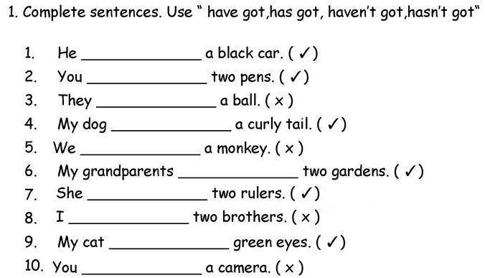

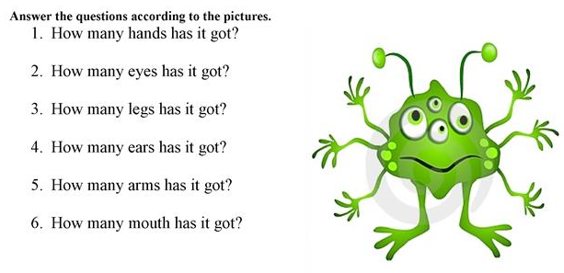

3- Complete using HAVE GOT- HAS GOT.

1- I _________________ a new mobile phone. (+)
2- The students ________________ computers in the classroom. (-)
3- He _______________ a little dog. (+)
4- ______ you __________ brothers or sisters?
5- My friend ______________ a car (-)

