COLEGIO SEÑOR DE MAILÍN
PLAN DE CONTINUIDAD PEDAGÓGICA
PROF. JESSICA REYNOSO INGLÉS: 1ER AÑO
DESDE EL 6 DE ABRIL AL 16 DE ABRIL.
APRIL 7th
- Read about Steve.
Hello! I am Steve and I live in Miami, USA. I am 13 years old. I have got 1 brother. I live with my father, mother and brother. I have got a dog.
I am tall and thin. I am clean and friendly. I have got black hair and brown eyes.
My favourite sport is football and my favourite food is pizza.
My favourite subject at school is Maths.
I go to school at 7 o’clock. I play football and watch TV in the afternoons.

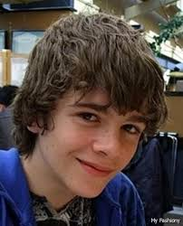

True or false?

- Steve is 13 years old. __________
- He lives with his mother and father. ____________
- He has got two dogs. _____________
- He has got brown eyes. ______________
- His favourite sport is Maths. ______________
- Complete the sentences with the verb BE (is- are- am)

- Steve ____________ 13 years old.
- I _____________ 16 years old.
- We _____________ students.
- They _________________ friends.
- I _________________ a teacher.
- She ________________ ugly.

- Complete the sentences with a subject pronoun.(we- they- he- she- it)

- Tom and Leila are friends. ___________ like hamburgers.
- My mother is a Doctor. _____________ works a lot.
- My cat is very clean. _____________ is friendly.
- Lucas has got brown hair. ___________ is 14.
- Leila and I are cousins. __________ are 25.

- Write the COUNTRY or NATIONALITY

1- Tom and Leila are Spanish. They are from _______________. 2- I am American. I am from _____________________. 3- My sister is from France. She is _______________________. 4- Where are you from? I am from Germany. I am ________________________. 5- Lucas is from Scotland. He is ________________________. 6- Are your grandparents Japanese? No, they are from China. They are ___________________.

- Now, write about you. Complete the description.
ABOUT ME
Hello! I am_________________ and I live in _____________________. I am _______ years old. I have got ________________. I live with ____________________________.
I am _______________ and ___________________.
My favourite sport is ________________and my favourite food is __________________.
I go to school at ________________.

9th APRIL- FERIADO
14th APRIL
DEMONSTRATIVE PRONOUNS. THIS- THAT- THESE- THOSE
USAMOS THIS Y THAT PARA REFERNIRNOS A UN SOLO OBJETO (EN FORMA SINGULAR) CON LA DIFERENCIA DE QUE THIS SE USA CUANDO EL OBJETO ESTA CERCA Y THAT SE USA CUANDO EL OBJETO ESTA LEJOS.
USAMOS THESE Y THOSE PARA REFERIRNOS A DOS O MÁS OBJETOS (EN FORMA PLURAL) CON LA DIFERENCIA DE QUE THESE SE USA CUANDO LOS OBJETOS ESTAN CERCA Y THOSE SE USA CUANDO LOS OBJETOS ESTAN LEJOS.
EXAMPLES:
THIS IS A BOOK (ESTE ES UN LIBRO)
THAT IS A PEN (AQUELLA ES UNA LAPICERA)

THESE ARE RUBBERS (ESTAS SON GOMAS)

THOSE ARE RULERS (AQUELLAS SON REGLAS)
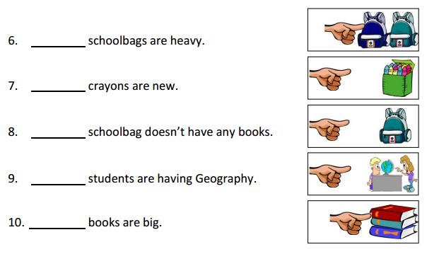
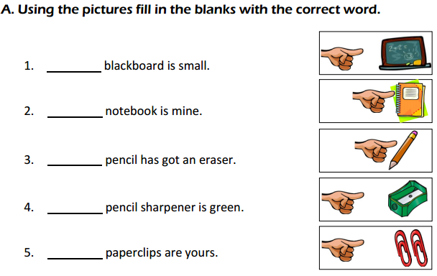

B- LOOK AT THE PICTURES AND WRITE SENTENCES. USE THIS- THAT-THESE- THOSE.
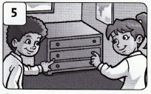
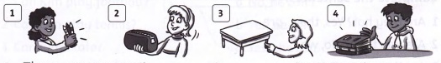

1- _____________________PENCILS. 4- ________________________BOOKS.
2- ____________________ A PENCIL CASE. 5- ________________________ DRAWERS.
3- _____________________ A TABLE.

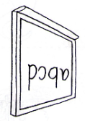
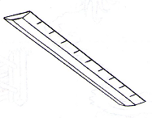
C- Look at the pictures and make sentences using THIS- THAT- THESE- THOSE.
1- THIS IS A RULER 2- _____________________________

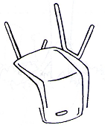
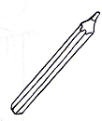
3- ___________________ 4- ________________________

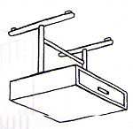
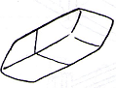
5- ___________________ 5- ___________________

D- Change the sentences from SINGULAR to PLURAL. Remember to change the verb “BE”.
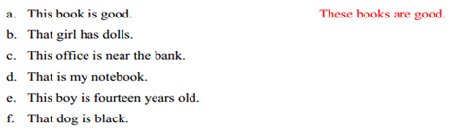

E- Correct the mistakes. (Corregir los errors)
