COLEGIO SEÑOR DE MAILÍN
PLAN DE CONTINUIDAD PEDAGÓGICA
PROF. JESSICA REYNOSO
INGLÉS: 2DO AÑO
DESDE EL 2 DE ABRIL AL 17 DE ABRIL. (2 feriados en el medio por semana santa)
2th APRIL
REVISION
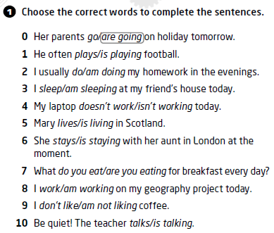
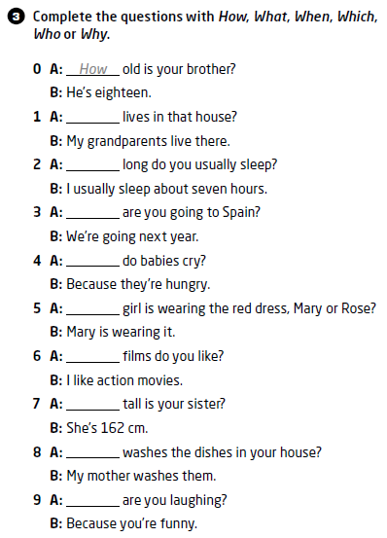

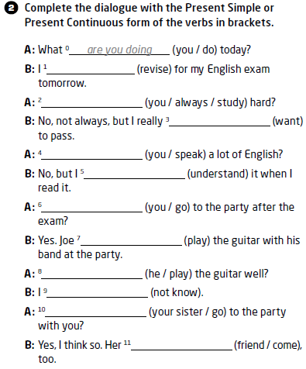

3th APRIL

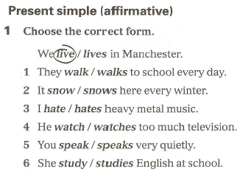
PRESENT SIMPLE.
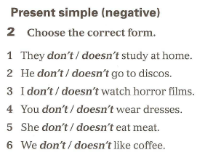

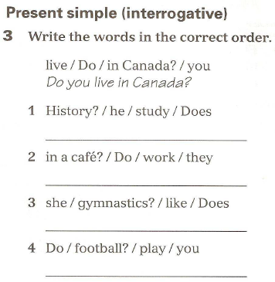
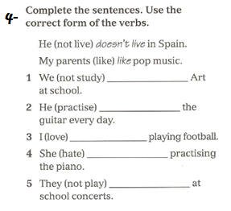

PRESENT CONTINUOUS
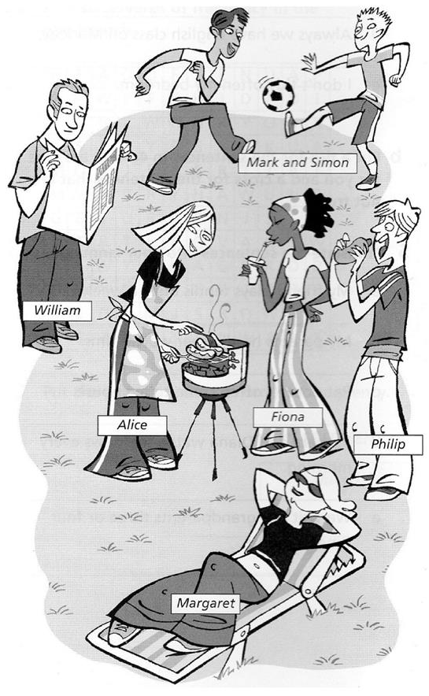
What are they doing? Make sentences.
EXAMPLE:
MARK AND SIMON ARE PLAYING FOOTBALL.

9TH and 10th APRIL (FERIADOS SEMANA SANTA)
16th APRIL
MORE PRACTICE
1- Complete the following sentences with present simple or present continuous
1. Hello! Where __________you ________________ (go) now?
2. I usually (do) _______________my homework after dinner.
3- The lesson (begin) ___________________at 8 every morning.
5- He sometimes (go) ____________________to the pub.
6- I (not- listen) _____________________to the radio very often.
7- The shop (open) _________________at 8 o‘ clock every day.
8- He (not- come) ________________________to visit my mother every week.
10- He (study)________________________ English this year.
11- They usually (have) ____________________dinner at 7 o'clock.
12- He usually (watch) ______________________TV on Sundays.
13- She (look) _________________________ for a new house to live at the moment.

2- Match the sentences with the correct QUESTION WORD.
a- ___________ is your teacher?
b- ___________ do you live?
c- ___________ is summer?
d- ___________ is your favourite animal?
e- ___________ do you go to school?
f- ___________ are you sad?
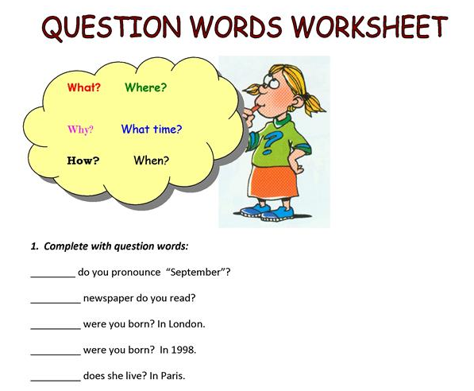

17TH APRIL
READING COMPREHENSION
- Read about Olivia. Then decide if the sentences are TRUE or FALSE.
Hello! I am Olivia. I am nineteen years old. I live in Cambridge, England with my mother Susan, my father John and my brother Bruno. We have a small family. I have got two dogs.
Every day I get up at half past six and then I have breakfast at seven o’ clock. I eat biscuits and I drink chocolate milk. My brother always drinks coffee and my parents drink mate. I go to university at 11 o’clock every day but today I am staying at home because I don’t have classes.
At the weekend, I usually go shopping or to the cinema with my friends. We love watching films! I really like shopping. I buy clothes on the internet. I always buy jeans and shirts.
Every Saturday night I visit my grandparents and we eat pasta all together and we have ice cream or cake for dessert.

a- Olivia is 18 years old and she lives in England. _______________ b- She has got two brothers. ______________ c- She never has breakfast. _______________ d- Olivia goes to school at 11 o’clock. ______________ e- She doesn’t have classes today. ______________ f- She buys online. ______________
2- Answer the following questions about Olivia.
- What time does she get up? ________________________________________________________________
- What does John have for breakfast? _________________________________________________________
- What does she do at the weekend? __________________________________________________________

3- Choose the correct option between PRESENT SIMPLE or CONTINUOUS.

a- I am studying / study at school at the moment. b- I always have dinner / am having dinner at home. c- Steve never goes / is going to the cinema. d- What are you doing / do you do now? e- My brother isn’t eating / doesn’t eat salad every day

Adverbs of frequency
A) Put the adverbs in the correct place in the diagram
NEVER HARDLY EVER SOMETIMES ALWAYS USUALLY- OFTEN
100 % 80% 60 % 40% 20% 0% 0% 0% 0%

…ALWAYS……… ……………..………… …………………………… …………………………… ................................ ...........NEVER..........

B) Write sentences that are true for you. Complete them with always, usually, often, sometimes, hardly ever or never. Escribe oraciones que sean verdaderas sobre vos agregando un adverbio de frecuencia.
1. I ______________play football after school.
2. My teachers ______________give us too much homework.
3. I ________________go to the cinema at the weekend.
4. My best friend _______________comes to my house at the weekend.
5. I ______________________watch TV in the morning.
c) Make sentences form the information in the table. RECUERDA LAS REGLAS DEL PRESENT SIMPLE (VERBO CON S O ES cuando el sujeto es HE-SHE-IT)
= always = usually = often
= sometimes X X = hardly ever X X X= never
 | 1.Louisa | 2.Ben | 3.Sue
Get up early
Read a book | X X X
Listen to music
Go to the cinema | X X

WRITE 12 SENTENCES (4 FOR EACH PERSON) Escribe 12 oraciones (4 para cada persona)
1- LUISA USUALLY GETS UP EARLY.
2. LUISA NEVER READS A BOOK.
3. LUISA SOMETIMES LISTENS TO MUSIC
4. LUISA HARDLY EVER GOES TO THE CINEMA.
5.
6.
7.
8.
9.
10.
11
12.

