COLEGIO SEÑOR DE MAILÍN
PLAN DE CONTINUIDAD PEDAGÓGICA
PROF. JESSICA REYNOSO
INGLÉS: 2DO AÑO
DESDE EL 18/5 al 29/5
May 21st
1- Read the text and then decide if the sentences are TRUE or FALSE.
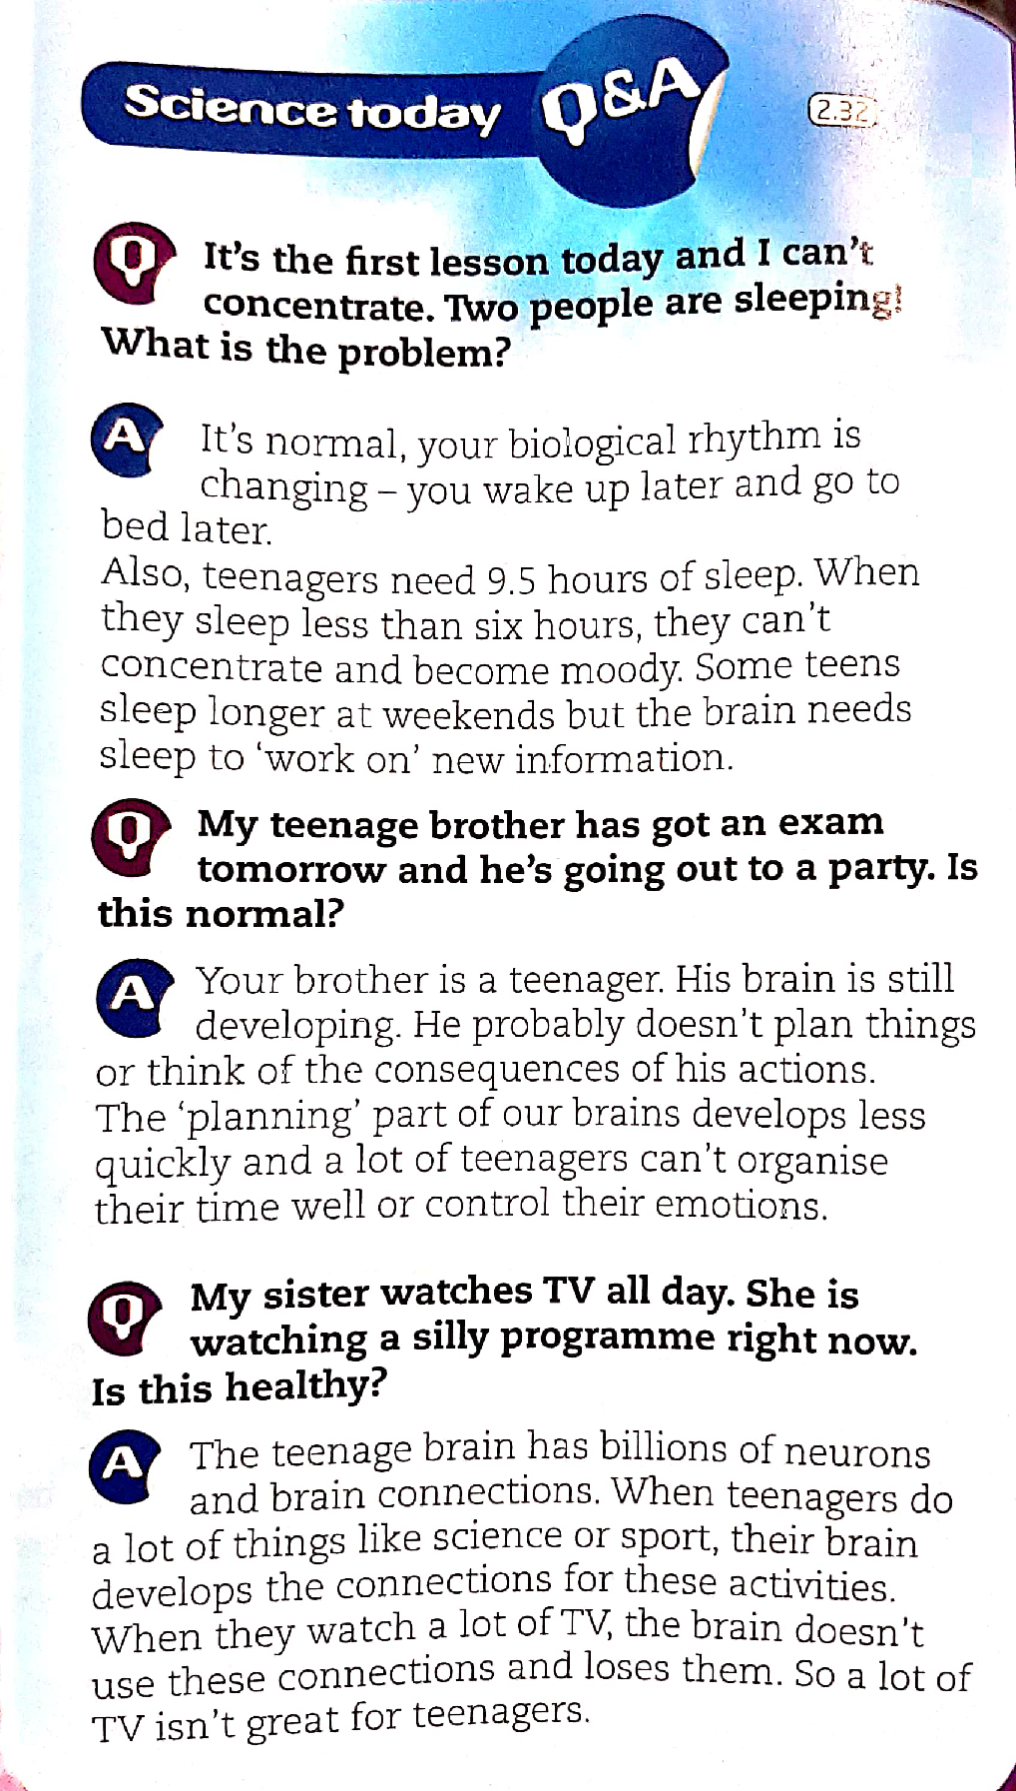

1- When you are a teenager, it is normal to go to bed later. ____________
2- Teenagers need to sleep more than 8 hours. ____________
3- They can control emotions. __________
4- Teenagers aren’t good planners. ________
5- The brain has got millions of neurons and brain connections.
6- It is good for teenagers to do sports or things connected to science. ____________

2- Read the examples in the chart and complete with PRESENT SIMPLE or PRESENT CONTINUOUS.
Find and underline more sentences in the text of PRESENT SIMPLE AND CONTINUOUS. Use different colours.
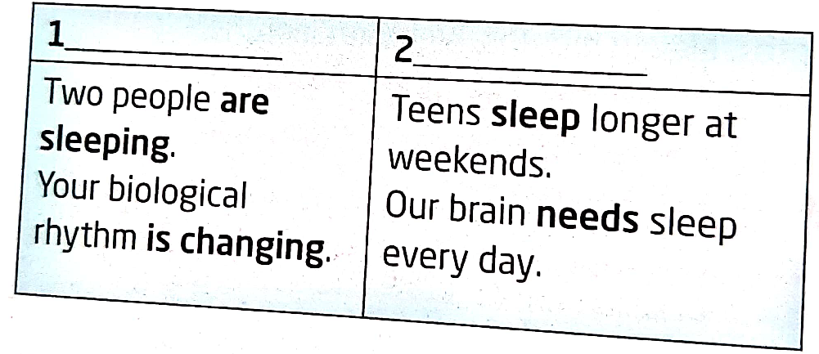

3- What tense do we use to express: circle the correct option.
a- things happening NOW. PRESENT SIMPLE/ PRESENT CONTINUOUS.
b- Things happening REGULARLY or ALWAYS true. PRESENT SIMPLE/ PRESENT CONTINUOUS.
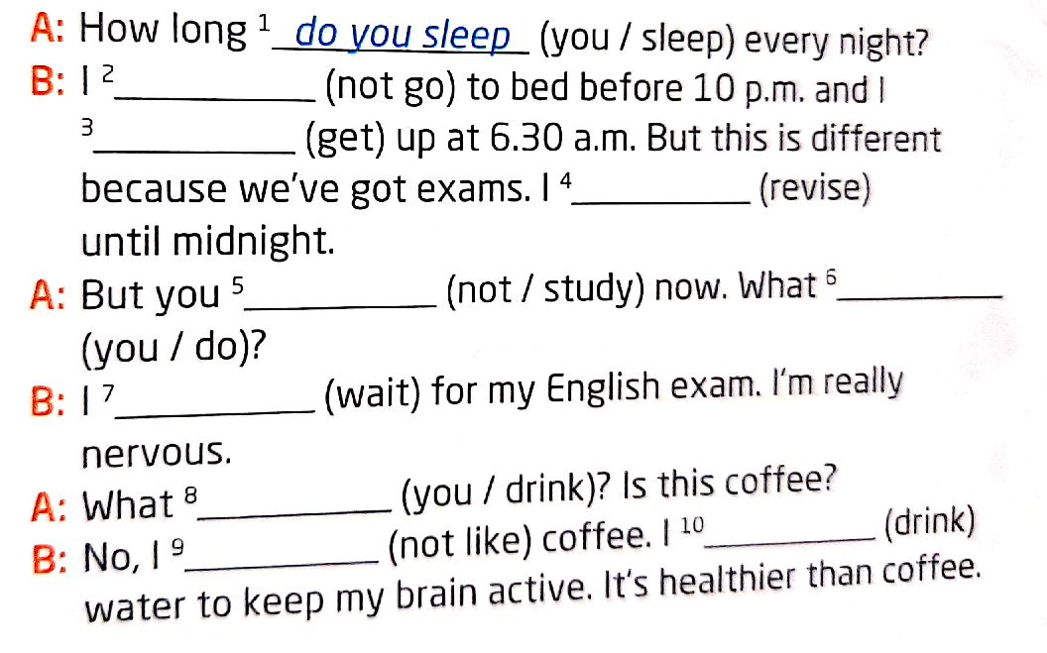
3- Complete the interview with the verbs in brackets in the present simple or continuous.

4- Answer these questions
a- WHAT TIME DO YOU GET UP?
b- WHAT IS YOUR MOTHER DOING NOW?
c- WHAT DO YOU DO AT THE WEEKEND?
d- WHAT TIME DO YOU USUALLY GO TO BED?

May 22nd
LEARN THIS!
COMPARE THESE TWO SENTENCES:

I ALWAYS HAVE BREAKFAST IN THE KITCHEN IT IS A ROUTINE (PRESENT SIMPLE)

TODAY I AM HAVING BREAKFAST IN BED. IT IS HAPPENING NOW (PRESENT CONTINUOUS)

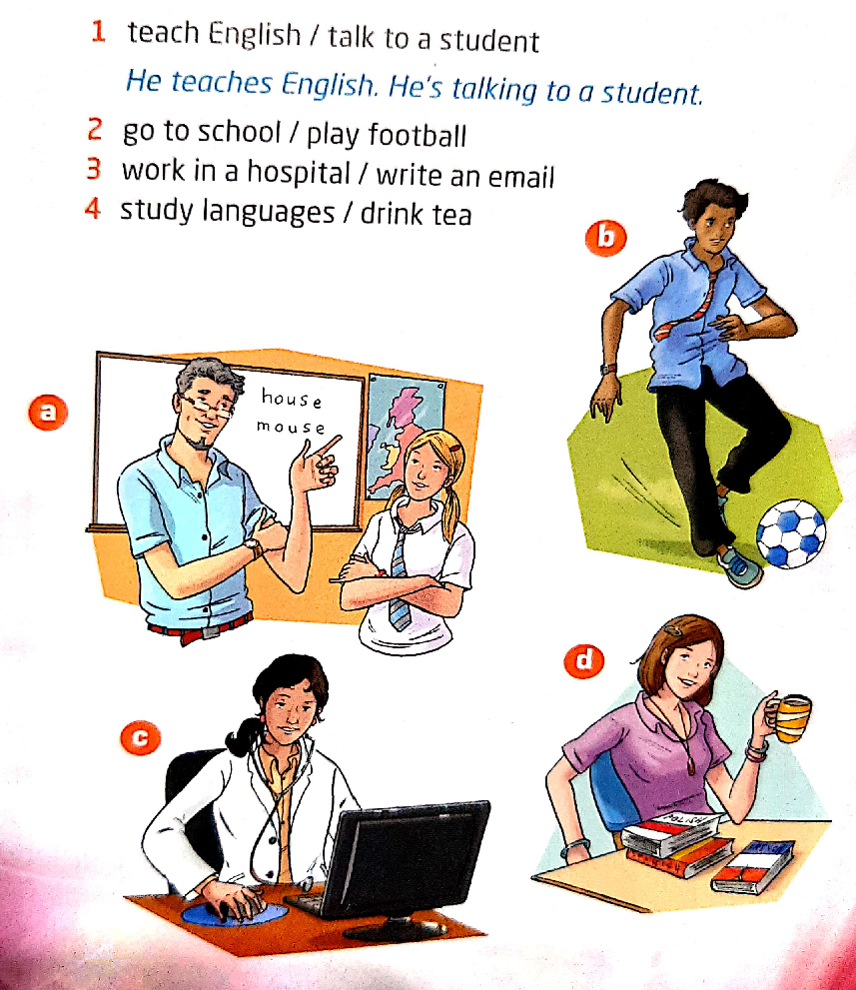
1- Look at the pictures and use the phrases to write TWO sentences for each picture. ONE in the present simple and ONE in the present continuous. FOLLOW THE EXAMPLE.

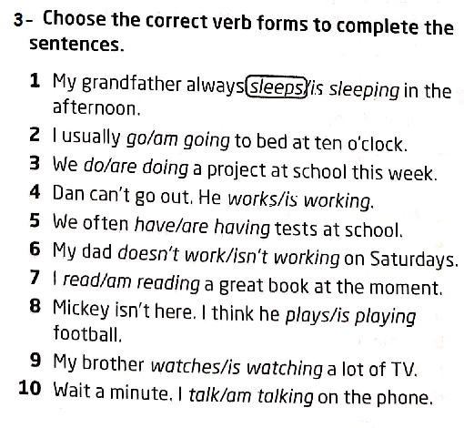
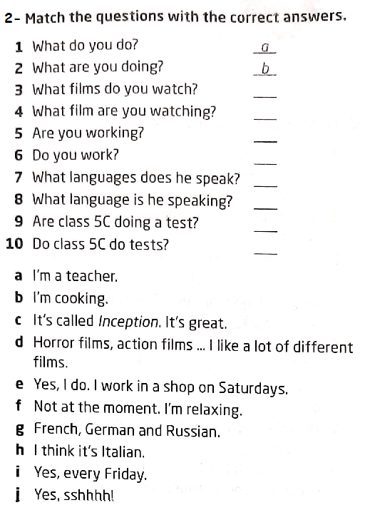

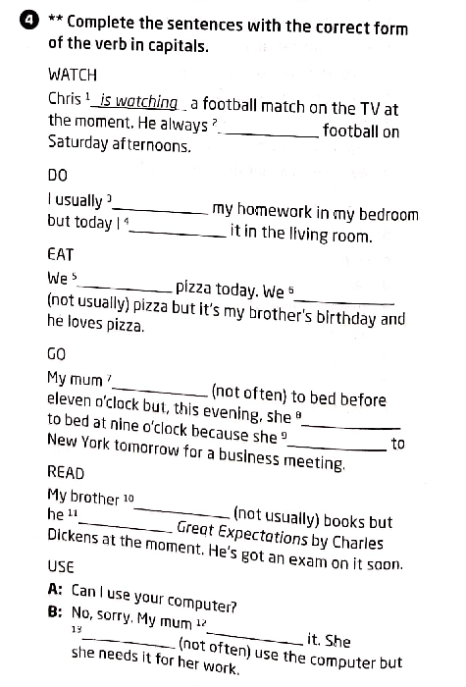

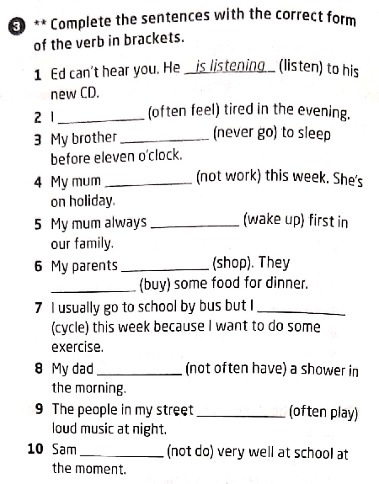

May 28TH
LET’S REVISE VOCABULARY: DAILY ROUTINES.
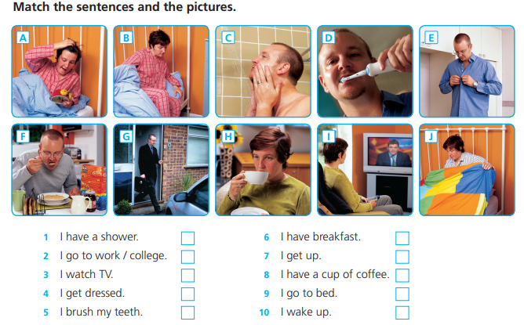
1-

2- WHAT TIME DO YOU DO THESE THINGS? MAKE SENTENCES AND ADD ADVERBS OF FREQUENCY.
a- I ALWAYS have a shower in the morning at 8 o’clock.
b- I NEVER get up at 10 o’clock.
c- _________________________________________________________
d- __________________________________________________________
e _________________________________________________________
f - _________________________________________________________
g- _________________________________________________________
h-___________________________________________________________
i- __________________________________________________________
j- __________________________________________________________

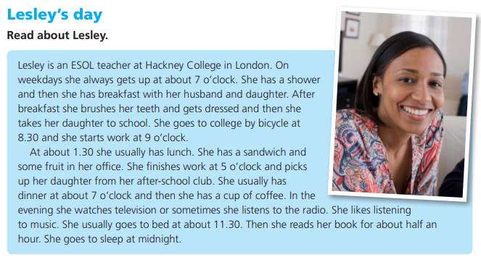
May 29TH
1-

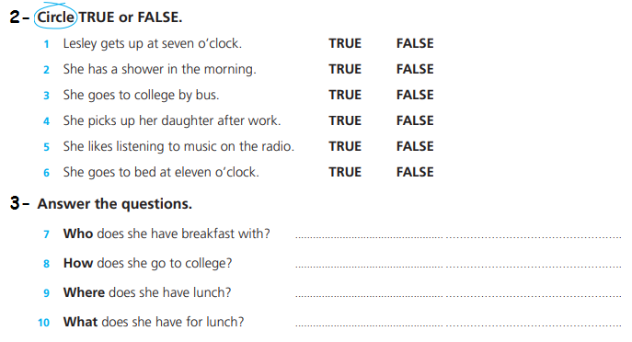

4- NOW IT IS YOUR TURN. WRITE A SHORT PARAGRAPH TELLING ABOUT YOUR ROUTINE.
YOU CAN WRITE SENTENCES IF YOU PREFER.
*ES TU TURNO! ESCRIBÍ UN BREVE PÁRRAFO CONTANDO SOBRE TU RUTINA. PODÉS ESCRIBIR ORACIONES SUELTAS SI LO PREFIERES. RECORDÁ USAR EL VOCABULARIO DE RUTINAS!
My daily routine

