COLEGIO SEÑOR DE MAILÍN
PLAN DE CONTINUIDAD PEDAGÓGICA 4
PROF. JESSICA REYNOSO INGLÉS: 1ER AÑO
DESDE EL 8 DE JUNIO AL 19 DE JUNIO
June 9th
LET’S REVISE!

1- Read about Sarah. Then decide if the sentences are TRUE or FALSE.

Hello! I am Sarah and I live in London, England. I am 13 years old. I have got 1 brother, He is John. He is 22 years old. I live with my father and mother. I have got a cat. I am tall and thin. I am intelligent and friendly. I have got long hair and green eyes.
My favourite subject at school is Science. I love experiments. My favourite sport is football and my favourite food is chicken and chips.
I go to school at 7 o’clock. My school is big and old. Classes start at 8 o’clock and finish at 1 o’clock. On Mondays I have English, Science and Maths. Monday is my favourite day at school!

- John is 13 years old. __________
- Sarah lives with his mother and father. ____________
- She has got two cats. _____________
- She has got brown eyes. ______________
- Sarah’s school is small. ______________
- Sara’s favourite school is Monday. _______________
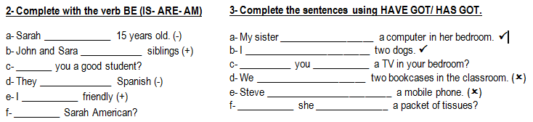

4- Complete the sentences with demonstrative pronouns: THIS- THAT- THESE- THOSE.

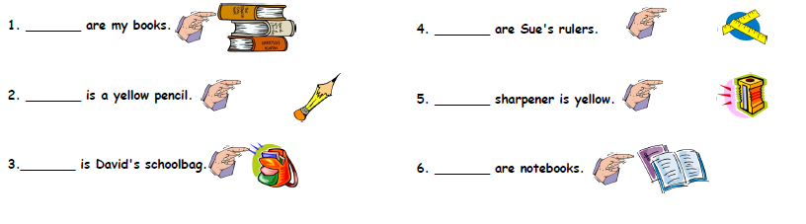

June 11th
1- Look at the pictures and complete the sentences using CAN- CAN’T and a verb from the list.
SING – COOK – WALK - PLAY
1- he ________________________ . 3- they _______________________.
2- she ____________________ tennis. 4- she _______________________.

2- Look at the information and write sentence. Complete the ME column.
CAN... | SING? | DANCE? | SWIM? | COOK?

JACK

SOPHIE
ME

Example: Jack can sing and swim. Jack can’t dance or cook.
SOPHIE _________________________________________
I ______________________________________________

3- Look at the family tree and complete with a FAMILY MEMBER.

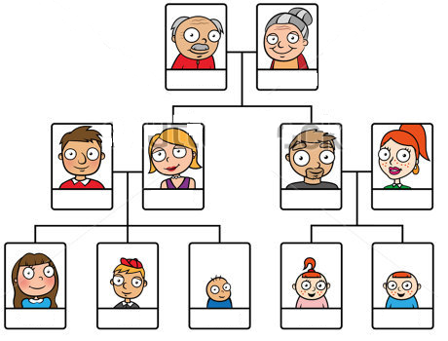
a- John is Tina ‘s _______________ b- Laura is Tina’s ________________ c- Steve is Laura’s _______________ and Tina’s ________________. d- Luli and Simon are Steve’s ___________________. e- Grace is Susan’s ___________________ f- Robert is Laura’s ________________ and Tina’s _______________. g- Tina, Steve and Sophie are Ben’s ____________________. h- Laura is Ben’s ____________.

June 16th
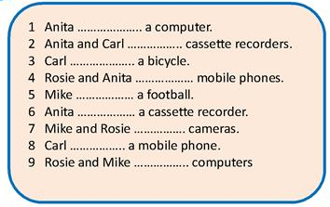
1- COMPLETE WITH HAVE GOT / HAS GOT

2- Complete the sentences with the verb “BE” and a COUNTRY or NATIONALITY
1- I ________ ENGLISH. I ______ FROM SPAIN. 2- MY SISTER _________ BRAZILIAN. SHE _________ FROM ____________. 3- WE _____________ SPANISH. WE _________ ARGENTINEAN. 4- MY NEW FRIENDS __________ AMERICAN. THEY _________ ITALIAN. 5- ________ TOM FROM JAPAN? NO, HE ___________, HE _________ CHINESE.
3- Write these sentences in the negative and interrogative.
1- I am seventeen years old. 2- My sister is a good student. 3- We are good at sports. 4- Jason is my cousin.
4- Choose the best word a, b or c to complete the sentences.
0 Your mother’s mother is your __________ .
a grandmother b cousin c wife
1 Tom’s parents are very young: his mother is 35 and his __________ is 37.
a husband b uncle c father
2 I’ve got one __________ and two brothers.
a sister b aunt c wife
3 My father’s brother is my__________.
a uncle b grandfather c cousin
4 Mrs Brown has got one __________ and two sons.
a child b daughter c sister
June 18th
EX 1- Read the text and answer TRUE or FALSE
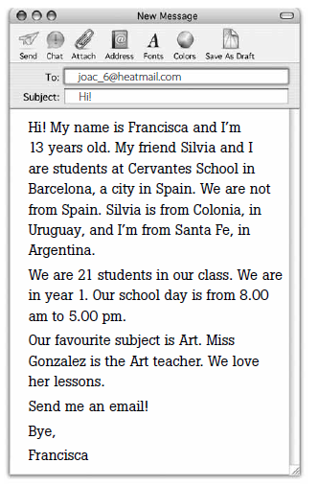

1- Francisca is from Barcelona. ______
2- Cervantes is a primary school. ______
3- Silvia is a teacher. ______
4 -Miss Gonzalez is an Art teacher. ______
5- Francisca is 9 hours at school.________

2- Read the text and complete.

1 Francisca is _____________ years old.
2 Silvia is ___________ friend.
3 Silvia and Francisca
_____________students.
4 _________are in year 1.
5 __________ favourite subject is Art

3- Circle the correct option.

1 Marianela is / are from Nicaragua.
2 We isn’t / aren’t 25.
3 Salta and La Plata am / are cities.
4 Are / Am you Italian?
5 I am / are José Luis.

4- Complete with the affirmative form of the verb to be.

1 Buenos Aires ___________the capital city of Argentina.
2 Spain __________in Europe.
3 Africa and South America ___________continents.
4 Kenya and Egypt____________ countries.
5 I __________your friend.

